**Experiment No 10**

**Investigate the performance of Rankine cycle**

**Introduction:**

The **Rankin cycle** is the process widely used by power plants such as coal-fired power plants or nuclear reactors. In this mechanism, a fuel is used to produce heat within a boiler, converting water into steam which then expands through a turbine producing useful work.

The **Rankin cycle** is a model used to predict the performance of **steam turbine** systems. It was also used to study the performance of reciprocating **steam** engines. The **Rankine cycle** is an idealized thermodynamic **cycle** of a heat engine that converts heat into mechanical work while undergoing phase change as shown in fig no 10.1.

**Diagram:**

Fig no:10.1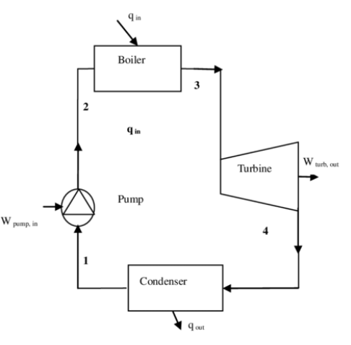

**Basic Principle:**

The **Rankin cycle** is an idealized thermodynamic **cycle** of a heat engine that converts heat into mechanical work while undergoing phase change. The heat is supplied externally to a closed loop, which usually uses water as the working fluid.

**Parts:**

* Steam Pressure
* Condenser Pressure
* Tachometer
* Temperature Indicator
* Break Load Indicator
* Break Cooling water control
* Steam Solenoid Valve
* Steam Outlet After Boiler
* Throttle Valve
* Belt Break
* Tachometer Optical Sensor
* Impulse Turbine
* Break Cooling water outlet
* Three pipe steam
* Gauge
* Boiler Pressure
* Pressure Leave valve
* Boiler leave indicator
* Nozzle

**Explanation of Parts:**

**Tachometer:**

Tachometer is a device which is used to measure the speed of the turbine. It allows turbine rotational speed to be evaluated.

A **tachometer** is an instrument **measuring** the rotation speed of a shaft or disk, as in a motor or other machine. The device usually displays the revolutions per minute (RPM) on a calibrated analogue dial, but digital displays are increasingly common as shown in fig(10.1)

**Temperature Indicator:**

* Nvis 607 is a simple **digital** general purpose

**temperature indicator** designed indicate **temperature** using a **sensor** of K-type.

* Due to the fact that there are different physical measuring principles depending on the sensor, diverse **temperature indicators** will be required. Pt100 resistance sensors can get changed with **temperature** and resistance. **Temperature indicators** should determine the current resistance as shown in fig(10.2)

**Fig no 10.2:**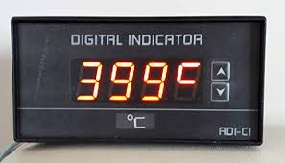

**Break Load Indicator:**

Steam flow to the turbine can be throttled by a hand

valve and the boiler turbine inlet and condenser pressures are indicated on gauges. The impulse turbines driven by a convergent divergent nozzle and turns a **brake** wheel with speed sensor and digital **indicator** allowing true shaft power to be determined.

**Break Cooling water Control:**

Those massive draw works disc **brakes** get hot. Their main

purpose is to **control** the speed of rotation by turning

rotational energy into heat energy. Additionally, if yours has a **water** cooling **system.**

The **brakes** are pneumatically actuated and **cooled** down through the use of a continuous flow of **coolant** from either an open or closed loop **cooling system**. **Water**-**cooled brakes** are found in a variety of industries and applications.

**Steam Solenoid Valve:**

**Steam Solenoid Valves**. The name given as **solenoid valve** to the electromagnetic **valve** used to control fluids such as water,air, **steam**, gas etc. ... When the electric current moves in the coil, the piston becomes the electromagnet and moves the piston according to the state of use of the coil.

**Throttle Valve:**

Designed to control **steam** flow and prevent catastrophic failure, a trip and **throttle** (T&T) **valve** is a critical safety device on a **steam turbine**. The reliability of a T&T **valve** is essential to ensure the safe **operation** of the **steam turbine** and the safety of personnel working around the equipment.

**Impulse Turbin:**

An **impulse turbine** is a **turbine** that is driven by high velocity jets of water or steam from a nozzle directed on to vanes or buckets attached to a wheel. The resulting **impulse** (as described by Newton's second law of motion) spins the **turbine** and removes kinetic energy from the fluid flow.

**Gauge:**

* 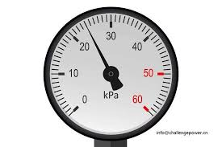A gauge or gage, in science and engineering,

is a device used to make measurements or in **Fig no 10.3:**

order to display certain dimensional information.

* A wide variety of tools exist which serve such functions, ranging from simple pieces of material against which sizes can be measured to complex pieces of machinery

as shown in fig(10.3).

**Safety Valve:**

A **safety valve** is a valve that acts as a fail-safe. An example of **safety valve** is a pressure relief ... **power generation**, food, drinks, cosmetics and pharmaceuticals industries, the term **safety valve** is associated with the terms pressure **relief valve** .

**Boiler Level Indicator: Fig no:10.4**

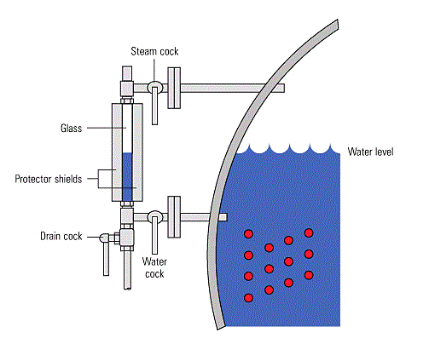 The **level** of water in a **steam boiler** must be carefully controlled, to ensure good quality **steam** is ... In most cases, the simple **gauge** glass on the **steam** / water **drum** or **boiler** shell is used as the **indicator**. ... The **boiler steam generation** rating.

As we know that simple **Rankin Cycle** is used in Power Plants and **boiler** is the indispensable part of a power plant. **Boiler** is the place where water gets converted into steam. Actually water takes up Latent heat of Vaporization from the heat supplied and changes to steam as shown in fig(10.4).

**Nozzle: Fig no:10.5**

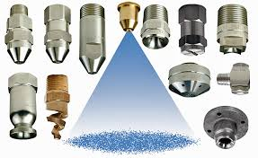 A **nozzle** is often a pipe or tube of varying cross sectional area and it can be used to direct or modify the flow of a fluid (liquid or gas). **Nozzles** are frequently used to control the rate of flow, speed, direction, mass, shape, and/or the pressure of the stream that emerges from them.

A nozzle is a device designed to control the direction or characteristics of a fluid flow as it exits an enclosed chamber or pipe. A nozzle is often a pipe or tube of varying cross sectional area and it can be used to direct or modify the flow of a fluid as shown in fig(10.5).

**Convergent-divergent nozzle:**

Suppose a **nozzle** is used to obtain a supersonic stream starting from low speeds at the inlet. It is clear that the **nozzle** must **converge** in the subsonic portion and diverge in the supersonic portion. Such a **nozzle** is called a **convergent**-**divergent nozzle**.

**Explanation:**

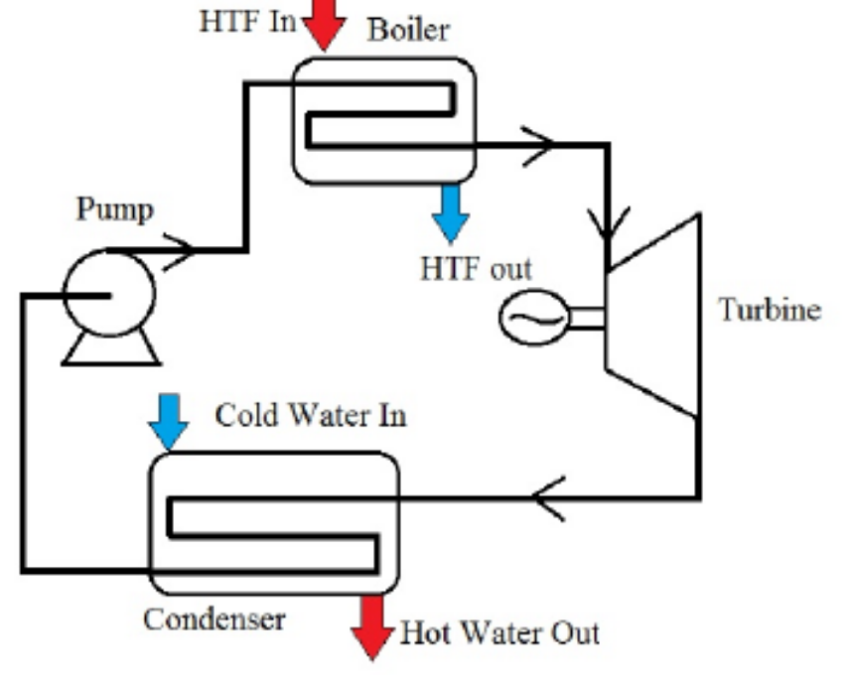

Fig no: 10.6

**Pump:**

Compression of the fluid to high [pressure](https://energyeducation.ca/encyclopedia/Pressure) using a pump (this takes [work](https://energyeducation.ca/encyclopedia/Work))

(Fig 10.6*:* Steps 1 to 2)

**Boiler:**

The compressed fluid is heated to the final [temperature](https://energyeducation.ca/encyclopedia/Temperature) (which is at boiling point), therefore, a [phase change](https://energyeducation.ca/encyclopedia/Phase_change) occurs—from [liquid](https://energyeducation.ca/encyclopedia/Liquid) to vapor. (Fig 10.6)

**Turbine*:***

Expansion of the vapor in the turbine. (Fig 10.6: Steps 3 to 4)

**Condenser:**

Condensation of the vapor in the condenser (where the [waste heat](https://energyeducation.ca/encyclopedia/Waste_heat) goes to the final heat sink (the [atmosphere](https://energyeducation.ca/encyclopedia/Atmosphere) or a large body of water (lake or river). Fig(10.6)

**Process:**

**Process 1–2**:

* The working fluid is pumped from low to high pressure. As the fluid is a liquid at this stage, the pump requires little input energy.
* In other words Process 1-2 is [Isentropic compression in pump]

**Process 2–3**:

* The high-pressure liquid enters a boiler, where it is heated at constant pressure by an external heat source to become a dry saturated vapor. The input energy required can be easily calculated graphically, using an [enthalpy–entropy chart](https://en.wikipedia.org/wiki/Enthalpy%E2%80%93entropy_chart) ([h–s chart](https://en.wikipedia.org/wiki/H%E2%80%93s_chart), or [Moliere diagram](https://en.wikipedia.org/wiki/Mollier_diagram)), or numerically, using [steam tables](https://en.wikipedia.org/wiki/Steam_table).
* Input is that material which is most common in the region or country.
* In other words Process 2-3 is [Constant pressure heat addition in boiler]

**Process 3–4**:

* The dry saturated vapor expands through a [turbine](https://en.wikipedia.org/wiki/Turbine), generating power. This decreases the temperature and pressure of the vapor, and some condensation may occur. The output in this process can be easily calculated using the chart or tables noted above.
* In other words Process 3-4 is [Isentropic expansion in turbine]

**Process 4–1**:

* The wet vapor then enters a [condenser](https://en.wikipedia.org/wiki/Surface_condenser), where it is condensed at a constant pressure to become a [saturated liquid](https://en.wikipedia.org/wiki/Boiling_point) by cool water.

**Important Points:**

* There should be water in boiler.
* There should be cold water at inlet of condenser.
* Before 85 psi, manual valve should be closed.
* At manual valve, pressure should be 85 psi.
* Maximum upper limit pressure of steam is 90 psi.
* Normal pressure of steam is 85 psi.
* Relief valve set pressure is 100 psi.
* Throttle valve should not be completely off. It is because, steam coming quantity is controlled by Throttled valve.
* There are two pipes for steam at top.
* There is only one pipe for water at top.

**Important Points about Condenser:**

**Heat Transfer Area:**

* When steam becomes liquid on pipe when touch it. Cold water is present at pipe of Condenser. Because cold water is used to cool the steam and heat is removed from steam and it becomes liquid. This happens when condenser pipe is straighten.
* Heat transfer area is **0.132 m2 .**
* Specific heat capacity = Cp = **4.18kJ / kg K**
* Surface area = **2πRl**
* Q = mCP*Δ*T (change in temperature, heated rod get cool in air)
* Q = hAs*Δ*T ( shape effect, As = heat transfer area )
* Cp of water > Cp of air

**Important Points about Turbine Rotor:**

* Blade pitch circle diameter = 45mm
* No of blades = **45**
* Blades inlet = **40o**
* Blades outlet = **40o**

**Break Load:**

* Pulley diameter = **40mm**

**Important Points about Turbine :**

* Throat diameter = **1.38mm**
* Exit diameter = **3mm**
* Discharge angle = **20o**

**Important Points about Turbine :**

* Nominal heat input= **6kW at 220 V** (depend upon main voltage )
* Maximum pressure control= **90 Psi**
* Normal pressure control= **85 Psi**
* Relief Valve= **100 Psi**

**Determination of torque, power and specific steam consumption:**

Torque = Force x Radius

At force = 0.77N

= 0.77 x 0.023

Torque= 0.01771Nm

At force = 1.03N

Torque = 1.03 x 0.023 = 0.02369Nm

**Power:**

**P =** T x W

= T x 2**π**N/60

At N= 375000RPM and T = 0.01771Nm

= 0.01771 x 2pi x 375000/60

Power= 695.12W

At N = 223000RPM and T = 0.02369Nm

= 0.02369 x 2**π** 223000/60

Power = 552.94W

**Mass Flow Rate:**

Mass flow rate = m / t

**For mass**

V= 200ml= 200 x 10^-3 x 1/1000

= 0.0002m^3

e = m/V

m = e x V

= 1000 x 0.0002

= 0.2

Mass flow rate = 0.2/117

= 0.00017kg/s

**Temperature Explanation:**

T1 = Turbine inlet temperature

T2 = Condenser outlet temperature

T3 = Cold water at condenser inlet (hot water)

T4 = Hot water at condenser outlet

T5 = Condensed water temperature that is in the Hollow condenser

T6 = Pump inlet (Tube makeup tank)

T7 = Boiler outlet (steam temperature)

T8 = Temperature after manual valve at outlet of boiler

**Efficiency of steam power plant:**

* The power plant that operates on coal constitutes almost 41% of the world’s electricity generation.
* It is the modified Rankine thermodynamic cycle on which the coal fired power plant operates.
* The overall efficiency of the coal power plant ranges from 32% to 42%. And this is calculated by the superheat pressures, and super heat and reheat temperatures of steam.
* Most of the large power plants that operates at steam pressures of 170 bar,570 ℃ superheat and  570 ℃ reheat steam temperatures can achieve the efficiency ranges from 35% to 38%.
* The efficiency of the super critical power plants operating at 220 bar steam pressure, 600/600 ℃ superheat/reheat temperatures can achieve is 42%.
* The efficiency in the range of 45 to 48% can be achieved by the ultra-super critical power plants operating at 300 bar pressure, 600/600 ℃ superheat/reheat steam temperatures.

### ****Advantages and Disadvantages****

The advantages and disadvantages of steam power plant are as follows:

#### Advantages:

* As compared with power generating plant, it has low initial cost and hence economical.
* Less land area is required as compared with the hydro power plant.
* Coal is used as fuel and the cost of coal is cheaper than petrol and diesel fuel. So the power generation cost is economical.
* This power plant has easy maintenance cost.

#### ****Disadvantages:****

* The running cost of steam power plant is comparatively high because of fuel, maintenance etc
* If we talk about the overall efficiency of steam power plant, than is about 35 % to 41% which is low.
* Due to the release of burnt gases of the coal or fuel, it contributes to the global warming to a larger extent.
* The heated water that is thrown in the rivers, ponds etc puts and adverse effect on the living organism of water and disturbs.